**SITE PARSER DOCUMENTATION**

Database UML Diagram:

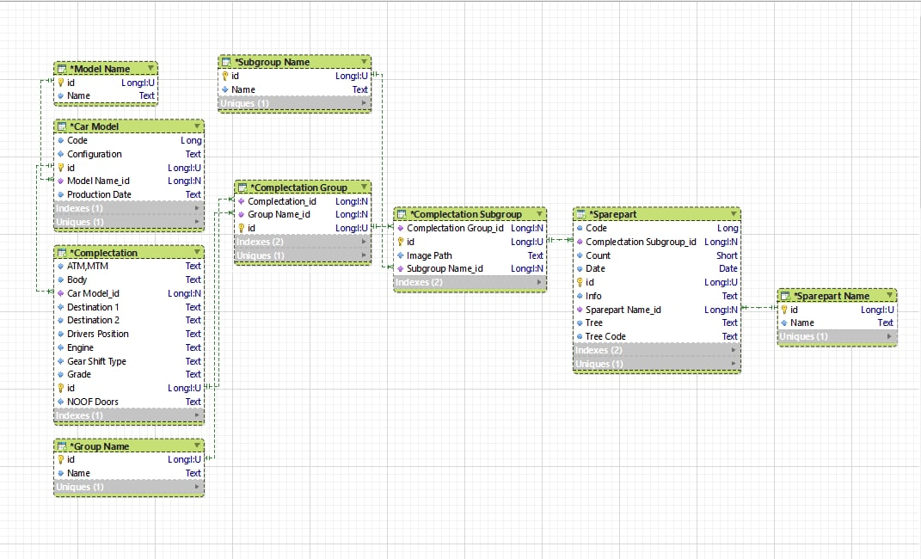

Database was created using first, second and third normal forms, and it differs from the proposed realization from test task.

Database creation in MSSQL:





